Queen’s College 155 Anniversary Quiz

1. Consider the number 39.
The smallest prime and the biggest prime factor of 39 are 3 and 13.
The prime numbers between 3 and 13 are 3, 5, 7, 11, 13.
Also, 39 = 3 + 5 + 7 + 11 + 13.
Find the next number that has each property.
(Hint: the number is bigger than 100 and it must not be a prime number.)

1 Ans. 155 = $5+7+11+13+17+19+23+29+31$

2. The number of vertices of a right prism is greater than the number of vertices of a right pyramid by 1. If the pyramid has 155 faces, find the sum of the number of edges of the two solids.

2 Ans. Number of faces of the pyramid = 155
Number of slant faces of the pyramid = 154
Number of edges of all slant faces = 154
The base of the pyramid is a polygon of 154 sides and therefore has 154 edges.
Totol number of edges of the pyramid = 154 + 154 = 308

Total number of vertices of the pyramid = 155
Therefore the total number of vertices of the prism = 156
The base and the top of the prism is a polygon of $\frac{156}{2}=78$ sides.
Number of edges of the of the prism = $78×3=234$
Total number of edges of the two solids = $308 +234 = \underline{542}$

3. $15!=15×14×13×…×1=1307674368000$
There are 3 trailing zeros. (Continuous number of zeros in the right side of the number.)
How many trailing zeros are there in $155!$

3 Ans. A trailing zero is formed when a multiple of 5 is multiplied with a multiple of 2. Now all we have to do is count the number of 5’s and 2’s in the multiplication.
Since a zero is created by $10=2×5$ and there are more factors of 2 than 5 in $155!$ , all we have to do is to count the factor 5 in the product.
Let’s count the 5’s first. 5, 10, 15, 20, 25 and so on, making a total $\left[\frac{155}{5}\right]=31$ , where $\left[x\right]$ denotes the largest integer smaller or equal to x.
However there are numbers 25, 50, 75, … which makes up two fives in each of them ($25=5×5)$, these number count up to $\left[\frac{155}{25}\right]=6$
Similarly, we need to count up numbers which have 3 fives as factors.
Number of trailing zeros = $\left[\frac{155}{5}\right]+\left[\frac{155}{25}\right]+\left[\frac{155}{125}\right]=31+6+1=\underline{38}$

4. Simplify $1\left(1!\right)+2\left(2!\right)+3\left(3!\right)+…+155\left(155!\right)$

4 Ans. $1\left(1!\right)+2\left(2!\right)+3\left(3!\right)+…+155\left(155!\right)$
$=\left[2\left(1!\right)+3\left(2!\right)+4\left(3!\right)+…+156\left(155!\right)\right]$
$-\left[1!+ 2!+ 3!+… + 155!\right]$
$=\left[2!+3!+4!+…+156!\right]-\left[1!+ 2!+ 3!+… +155!\right]$
$=\underline{156!-1}$

5. Find the centre number of the 155th row the Kordemsky’s triangular array. Find also the sum of all numbers in this row.
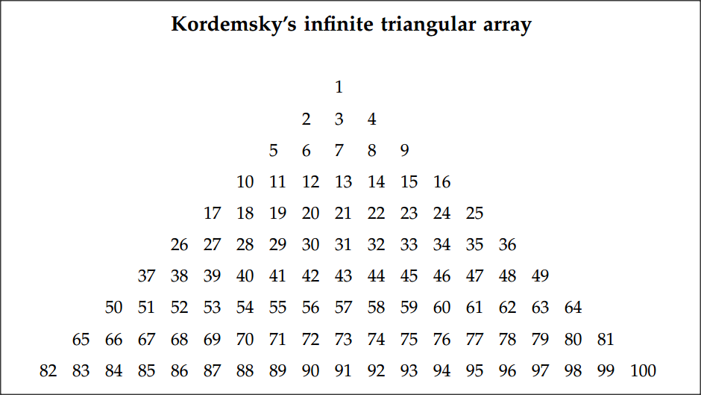

5 Ans. The last number of the n^{th} row = $n^{2}$
The centre number of the n^{th} row = $n^{2}-n+1$
The centre number of the 155th row = ${155}^{2}-155+1=\underline{23871}$
There are (2n – 1) numbers in the r^{th} row.
The first number in the n^{th} row = $n^{2}-\left(2n – 1\right)+1=n^{2}-2n+2$
The first number in the 155th row = ${155}^{2}-2\left(155\right)+2=23717$
Sum of all numbers in the 155th row = $\frac{2n-1}{2}\left(a+I\right)=\frac{2\left(155\right)-1}{2}\left(23717+{155}^{2}\right)=\underline{7376139}$

6. If $f\left(x^{2}-313x\right)=\left(x-155\right)\left(x-156\right)\left(x-157\right)\left(x-158\right)$, find $f\left(x-{155}^{2}\right)$.

6 Ans. $f\left(x^{2}-313x\right)=\left(x-155\right)\left(x-156\right)\left(x-157\right)\left(x-158\right)$
$=\left[\left(x-155\right)\left(x-158\right)\right]\left[\left(x-156\right)\left(x-157\right)\right]$
$=\left[x^{2}-313 x+24490\right]\left[x^{2}-313 x+24492\right]$
Hence, $f\left(x\right)=\left(x+24490\right)\left(x+24492\right)$
Replace x by $x-{155}^{2}$,
$f\left(x-{155}^{2}\right)=\left(x-{155}^{2}+24490\right)\left(x-{155}^{2}+24492\right)$
$=\underline{\left(x+465\right)\left(x+467\right)}$

7. The sequence $x_{1},x_{2},x_{3},…,x_{155},x_{156},…$ satisfies :
$x_{1}=\frac{1}{2}, x_{k+1}={x_{k}}^{2}+x_{k}$ where k = 1, 2, …, 155,….
Find the integral part (that is, excluding the decimal part) of the sum
$\frac{1}{x_{1}+1}+\frac{1}{x_{2}+1}+…+\frac{1}{x_{155}+1}$. (Hint: $\frac{1}{x_{1}}-\frac{1}{x_{1}+1}$.)

7 Ans. We have $\frac{1}{x_{1}}-\frac{1}{x_{1}+1}=\frac{1}{x_{1}\left(x_{1}+1\right)}=\frac{1}{x_{2}}$
Similarly, $\frac{1}{x_{2}}-\frac{1}{x_{2}+1}=\frac{1}{x_{3}}$
Work up to $\frac{1}{x_{154}}-\frac{1}{x_{155}+1}=\frac{1}{x_{156}}$
Add all these identities up, we have $\frac{1}{x_{1}+1}+\frac{1}{x_{2}+1}+…+\frac{1}{x_{155}+1}=\frac{1}{x_{1}}-\frac{1}{x_{156}}=2-\frac{1}{x_{156}}$
Since $x_{1}=\frac{1}{2}, x_{2}=\frac{1}{4}+\frac{1}{2}=\frac{3}{4}, x_{3}={\left(\frac{3}{4}\right)}^{2}+\frac{3}{4}=\frac{21}{16}>1$, we have
$x_{1}$<$x_{2}<x_{3}<…<x_{156}$ (More serious reader may use mathematical induction.)
Then $1=2-1<2-\frac{1}{x_{156}}<2-0=2$
The integral part of $\frac{1}{x_{1}+1}+\frac{1}{x_{2}+1}+…+\frac{1}{x_{155}+1}$ is 1.

16/4/2017
Yue Kwok Choy

